**We thank the reviewer and editor for re-considering our manuscript. We have substantially modified the manuscript to reflect these comments and suggestions as described in detail below:**

Reviewer #1: The manuscript PONE-D-14-30128 entitled “Gene Expression Signature in Adipose Tissue of Acromegaly Patients” by Hochberg et al. describes the analysis of the adipose tissue transcriptome form acromegaly patients vs. non-functioning adenoma patients, which revealed drastic changes in previously and newly identified targets related to metabolism, insulin and lipid pathways.

The rational of the study seems to be appropriate and well defined; however there are major study and technical limitations that lessen the relevance and impact of the study. It seems that the manuscript do not describe a technically sound piece of scientific research. It is not clear if the experiments have been conducted rigorously, with appropriate controls, replication, and sample sizes.

**As described below, we have provided justification for our modified analysis, taking age into account, also discussing our choice of controls and replication measures. We feel that these changes improve the technical soundness of our work. Ideally larger sample sizes from less phenotypically variable subjects would have been obtained, but given the rare nature of this disease and the lack of data with relative lack of information on effects in human patients our findings, even if not ideal provide an important dataset for future acromegaly research.**

Regarding the study design, it seems that non-functioning pituitary adenoma patients are not the appropriate controls in this study as they are not normal, healthy controls. Indeed, non-functioning pituitary adenoma patients can present several hormone dysfunctions and other comorbidities that could be impacting adipose tissue biology.

**Our opinion is that the non-secreting adenoma controls are technically a reasonable control, relative to “normal” controls. These samples are collected by the same surgeons using the same techniques and were processed identically. Furthermore these patients, even if not well age matched, do still have a pituitary tumor so we are controlling for this factor. To the concern that the non-functioning adenoma is phenotypically altering the physiology of these patients we propose to both mention this as a potential issue we have mentioned this as a caveat in the discussion with the following text:**

**One potential caveat to our approach is the use of patients with a non-secreting adenoma as the control group. To avoid the possible effects of hypopituitarism on adipose tissue we excluded patients with pituitary hormone deficiencies. We chose to include this as the control group as these samples not only collected in an identical manner from the same surgeons and processed identically, but also controls for potential non-secreting effects of pituitary tumor growths in the acromegaly subjects.**

In addition, the patients and controls are not age matched; while age has been shown to influence adipose tissue biology.

**The reviewer brings up an excellent point, as the previous analysis did not match the samples for age. To directly address this, we performed an additional supplementary analysis of the data wherein we separated the samples into subjects whom were over or above 60 years of age and repeated the analysis. This is described in the methods section as such:**

**To account for potential age-dependent changes in the subjects, we separated the patients into two groups, based on the median value, under 60 years of age versus 60 and above. We then added this age group as a covariate along with the disease state.. We tested for interactions between the age group and the disease state for each gene and did not identify any interaction term after adjusting for multiple observations (q<0.05). All fold changes provided in this manuscript are age-adjusted fold change values calculated from this regression.**

**After this analysis we found that after controlling for age, we observed 418 genes that were significantly different between acromegaly and control patients. We have provided a new Supplementary Tables 2-4 describing these data, and their associated pathway analyses. We also tested whether there were age-dependent differences in either our control or acromegalic groups and found 1 significantly different gene in the acromegalic group and none within the control group. This is now described in the results section with updated p-values adjusting for the age differences.**

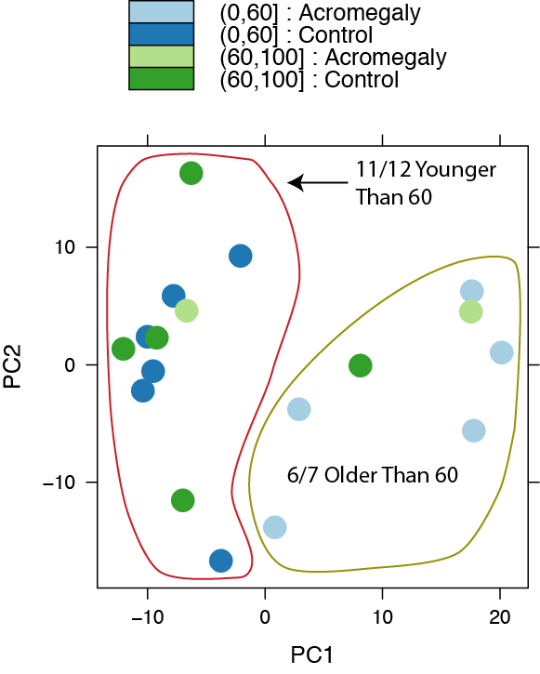

**Figure 1: Principal component analysis of RNAseq data.** Principal component analysis of normalized and variance stabilization transformed counts data for all transcripts. Shows good separation, along the first principal component of older and younger patients.

**As the reviewer suspected, some previously reported genes and pathways were no longer significantly different after this adjustment, and therefore the results section has been re-written, only taking into account only the age-adjusted fold changes and q-values. We feel that this change in analysis improved the reliability of our data, since we observed only a small decrease in the total number of statistically significant genes, but the number of statistically significant pathways identified by GSEA analysis was dramatically increased. This suggests that the genes which are enriched by the age-adjusted analysis cluster in pathway-specific modules, strengthening the biological relevance of our data. Furthermore, as shown in Figure 1 of this response, adding the age factor into our analysis dramatically improved the clustering of our data, as determined by principal component analysis, which shows that the first principal component separates older subjects from younger subjects with one exception in each case.**

Furthermore, it is not clear if the authors had into account the acromegaly onset, which is crucial to determine the time of high GH exposure.

**As acromegaly is a very slow disease, with a delay of diagnosis of about 10 years in average, we cannot know the exact onset of disease. Exposure to excess growth hormone has most likely been for several years prior to the collection of the biopsy.**

**Our two older acromegaly patients also had the mildest disease, with lower IGF1 levels, so we cannot discriminate if their milder gene expression change is secondary to lower GH/IGF1 levels or due to their age. This is mentioned in the results as follows:**

**Note that the older subjects had lower serum IGF-1 than the younger subjects, indicating that circulating IGF-1 levels may correlate with generally reduced transcriptional changes observed in the older acromegalic patients (Figure 3C).**

**Consistent with this, we found that the magnitude of the differences between older and younger acromegalics tended to also be smaller. Again, whether this is due to duration of exposure, or age-dependent differences in the disease cannot be determined from these studies. This is mentioned in the discussion as follows:**

**Interestingly, we observed more modest gene expression changes in general for older acromegalic patients than for younger patients. We are unable to determine from our study how long patients were acromegalic prior to our study, so one possibility is that the older patients have had longer to adapt to elevated GH levels. Alternatively, elevated GH/IGF-1 signaling may play a stronger role in younger patients.**

Regarding the experimental approach, it seems that the authors did not further validate the transcriptomic analysis by qPCR or western-blot, which drastically lessen the reliability of the results.

**To address the reproducibility of our findings, we have extensively compared our findings to published data both from single gene studies and from microarray studies on tissue culture cells. Neither of these are as broad in scope as our findings, but we have found good correlations between our findings and those of others in most cases, importantly for*, IGF1, PTPN3, SOCS2, CISH, LPL* and *HSD11B1*. In cases where we have not observed similar gene expression changes as proposed in the published literature we have discussed these as well, such as for *PIK3R1.* These independent descriptions provide solid validation for the reliability of our data.**

**We had considered performing qPCR studies to ‘re-validate’ some of our gene-expression findings but there is little evidence that qPCR analyses from the same samples will add any extra validity to our data so we decided to eschew those experiments. Previous studies have shown extremely close correlations between qPCR and RNAseq data (Asmann et al., 2009; Griffith et al., 2010; Shi & He, 2014; Wu et al., 2014). Ideally, we would re-validate our findings in a separate cohort of acromegalic patients, but due to the difficulty in accessing these samples, those experiments are not possible at this time.**

It is neither clear why only 7 out of 9 patients were used for the study. In addition, the study lacks mechanistic studies and/or validations that confirms the direct action of GH on the analyzed genes.

**The missing two patients for whom we had phenotypic data but not RNAseq data were included in Figure 1 but not other analyses. This was described in the methods section:**

**These subjects corresponded to the patients described in Table 1, with the exception of subjects 29 and 31 (both acromegaly patients), which had clinical data but no RNAseq data.**

Other comments:

* Several of the results presented herein (glucose levels, insulin levels, lipolytic measurements) have been previously published by other. However, some of them did not reach statistical significance herein, reflecting the fact that the number of patients and/or replicates could be too low to draw consistent conclusions.

**As acromegaly is such a rare disease (60 out of 1 000 000; Ayuk & Sheppard, 2006), it was a challenge to recruit even the 9 patients used in our study. Due to the heterogeneity in age, body type and natural history of these patients, it was not surprising that there were large variances in our samples. We did however reproduce previously described effects of acromegaly on height, fasting glucose, fasting insulin and HOMA-IR score and nearly observed statistical significance for isoproterenol-induced lipolysis in adipose tissue extracts (p=0.058). Our interpretation of these findings is that our subject pool is a reasonable phenotypic pool to interpret our molecular findings. Due to the lack of molecular findings associated with acromegaly, and our attempts to control for confounding factors such as age we feel that these data are a valuable contribution to the molecular phenotype of acromegalic adipose tissue.**

* It is surprising that the authors suggest adipose tissue relevant contribution to IGF plasma levels based on a mere correlation. Have the authors determined which is the real contribution of adipose tissue to IGF levels?

**We have speculated as to a role for adipose tissue in IGF1 production, but as the reviewer correctly points out, a direct assessment of the role of adipose tissue IGF1 to total serum IGF1 would require an adipose tissue specific *Igf1* knockout model, which is beyond the scope of these studies. This is described in the results section:**

**Serum IGF1 is primarily thought to be derived from liver tissue due to the observation that serum IGF-1 levels are reduced 75% in a liver specific IGF-1 knockout** (Haluzik et al., 2003)**. Our data demonstrates that expression of the adipose tissue *IGF1* gene correlates well with that of serum IGF-1. We can speculate that adipose tissue may be a source of IGF-1 in acromegalic subjects, potentially contributing to the remaining ~25% of IGF-1 that is not altered by liver-specific *Igf1* knockout. Further testing of this hypothesis will require adipocyte-specific ablation of *Igf1*.**

* The authors consistently refer to the effects of excess GH due to acromegaly, while acromegaly also curses with elevated IGF-I levels and therefore both elevated GH and IGF-I levels contribute to the final observed phenotype.

**As the reviewer suggests, we have pointed out in the introduction that all *in vivo* phenotypes associated with acromegaly may be due to either excessive GH or IGF-1 levels due to their known interactions:**

**Growth hormone induces the expression and secretion of IGF-1, so phenotypes associated with acromegaly may be due to either GH signaling, IGF-1 signaling or a combination of both.**

**We have also mentioned this point in the revised discussion:**

**Some of these genes may be direct targets of increased GH or IGF-1 signaling in adipose tissue, whereas others may be secondary adaptations to this condition.**

**Furthermore have also extended our analyses to include an evaluation of IGF-1 receptor levels in our dataset:**

**Neither the growth hormone receptor (GHR) nor the IGF-1 receptors (*IGF1R,* *IGF2R)* was significantly altered in acromegalic adipose tissue.**

# References

Asmann, Y. W., Klee, E. W., Thompson, E. A., Perez, E. a, Middha, S., Oberg, A. L., … Kocher, J.-P. a. (2009). 3’ tag digital gene expression profiling of human brain and universal reference RNA using Illumina Genome Analyzer. *BMC Genomics*, *10*, 531. doi:10.1186/1471-2164-10-531

Ayuk, J., & Sheppard, M. C. (2006). Growth hormone and its disorders. *Postgraduate Medical Journal*, *82*(963), 24–30. doi:10.1136/pgmj.2005.036087

Griffith, M., Griffith, O. L., Mwenifumbo, J., Goya, R., Morrissy, a S., Morin, R. D., … Marra, M. a. (2010). Alternative expression analysis by RNA sequencing. *Nature Methods*, *7*(10), 843–7. doi:10.1038/nmeth.1503

Haluzik, M., Yakar, S., Gavrilova, O., Setser, J., Boisclair, Y., & LeRoith, D. (2003). Insulin resistance in the liver-specific IGF-1 gene-deleted mouse is abrogated by deletion of the acid-labile subunit of the IGF-binding protein-3 complex: relative roles of growth hormone and IGF-1 in insulin resistance. *Diabetes*, *52*(10), 2483–9.

Shi, Y., & He, M. (2014). Differential gene expression identified by RNA-Seq and qPCR in two sizes of pearl oyster (Pinctada fucata). *Gene*, *538*(2), 313–22. doi:10.1016/j.gene.2014.01.031

Wu, A. R., Neff, N. F., Kalisky, T., Dalerba, P., Treutlein, B., Rothenberg, M. E., … Quake, S. R. (2014). Quantitative assessment of single-cell RNA-sequencing methods. *Nature Methods*, *11*(1), 41–6. doi:10.1038/nmeth.2694